1. LINQ to Objects using an int array [Fig. 9.2]:
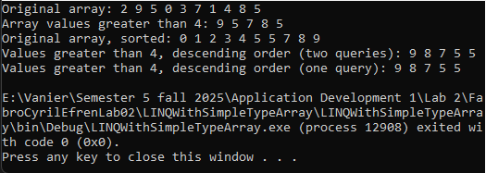

2. LINQ to Objects querying an array of Employee [Fig. 9.3, 9.4]:
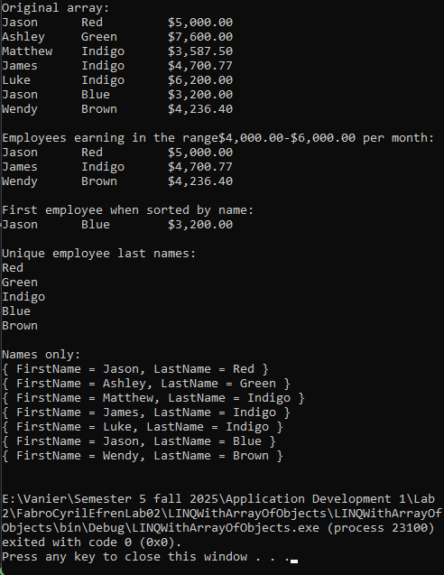

3. Generic LIST<T> collection demonstration [Fig. 9.6] :
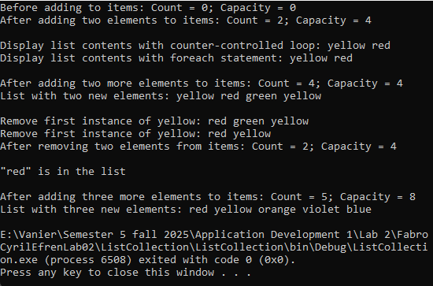
4. LINQ to Objects using a List<string> [Fig.9.7]:
